Changes made:

Part 1

1. Set activity=0 for feeding stations that were not visited
2. Include ‘season’ as a factor in the model instead of ‘month’. However, there is no data for Spring for the full moon phase
3. ANOVAs run for GUDs with log and arcsin transformation and with and without ‘feeding station’ as the error term
4. Repeat analysis with full moon phase dropped
5. Post-hoc analysis for interactions
6. 21/06: Test differences in # feeding stations visited across season, habitat and moon phase
7. 21/06: ANOVA for activity
8. 21/06: LMM for GUDs
9. 21/06: vegetation density difference between sparse and dense habitat

Part 2

1. Include cut/uncut as a factor in the model
2. Remove ‘day of cutting’ from model
3. Make number of days before and after cutting equal- there was initially three days of data before cutting and three days after
4. ANOVA and linear mixed effects model run for activity and GUDs
5. 21/06: Test differences in #feeding stations visited across Cut/Uncut trees and times of tree cutting

**Part 1.** *Effect of cover and moonlight on rodent feeding behaviour*

**Cover**

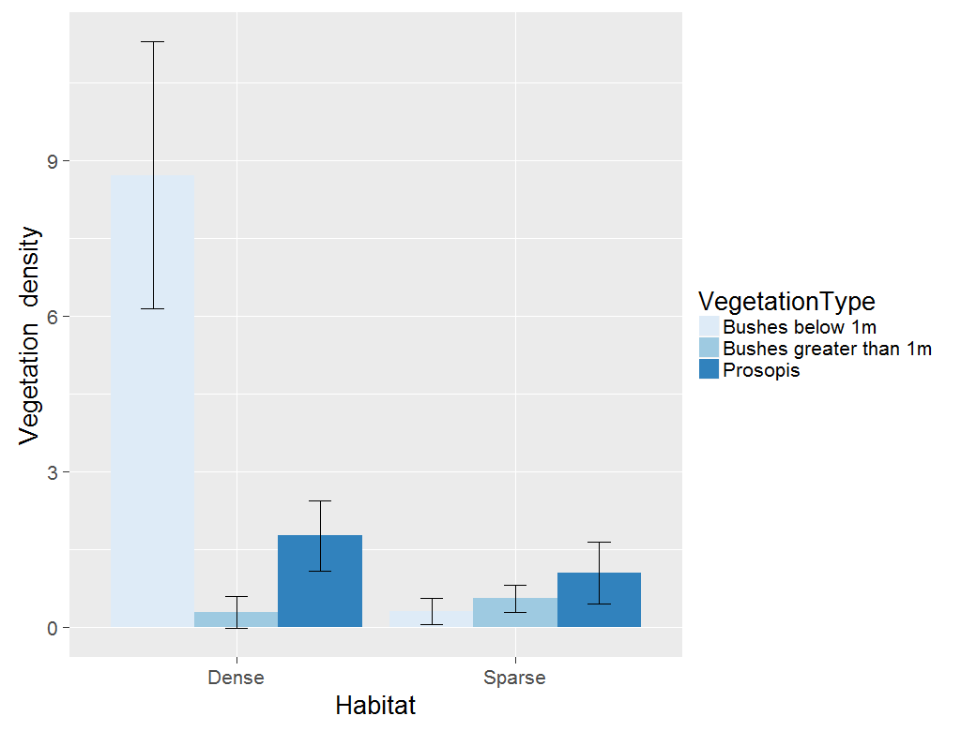

A Kruskal-Wallis test was used to examine differences in vegetation density between the two habitats as vegetation was not normally distributed. Total vegetation density is higher in the dense habitat (vegetationdense=3.5873 ± 0.6474 SE; vegetationsparse =0.6333 ± 0.1234 SE)) compared to the sparse habitat (2=15.8, p <0.001).

**Number of feeding stations visited**

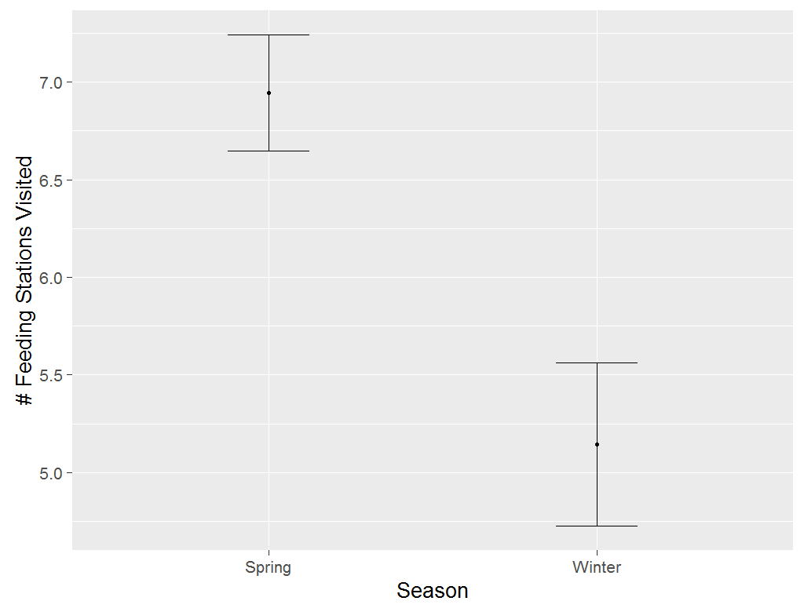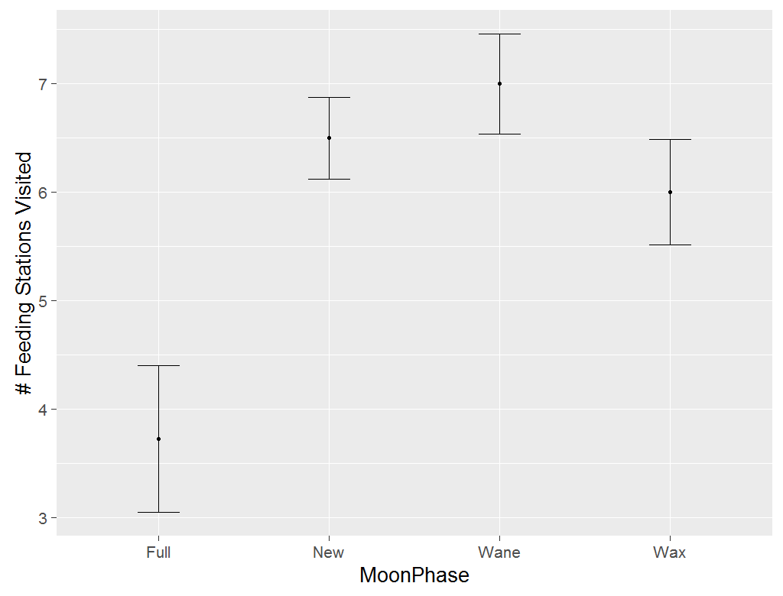

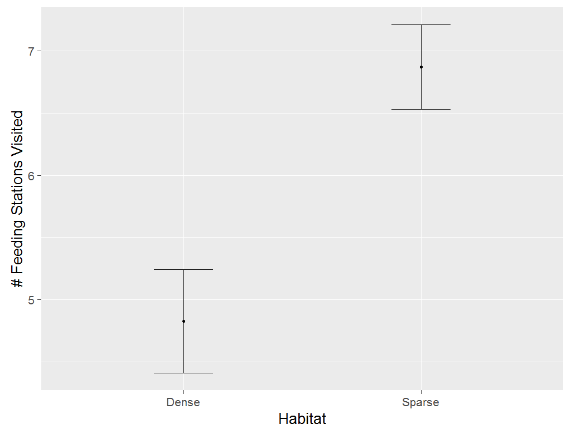

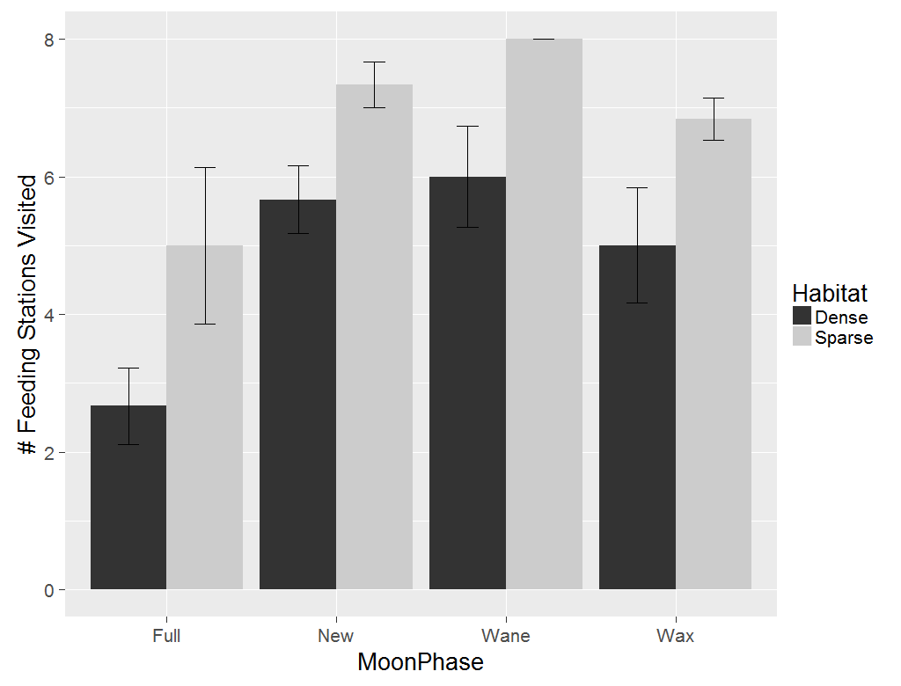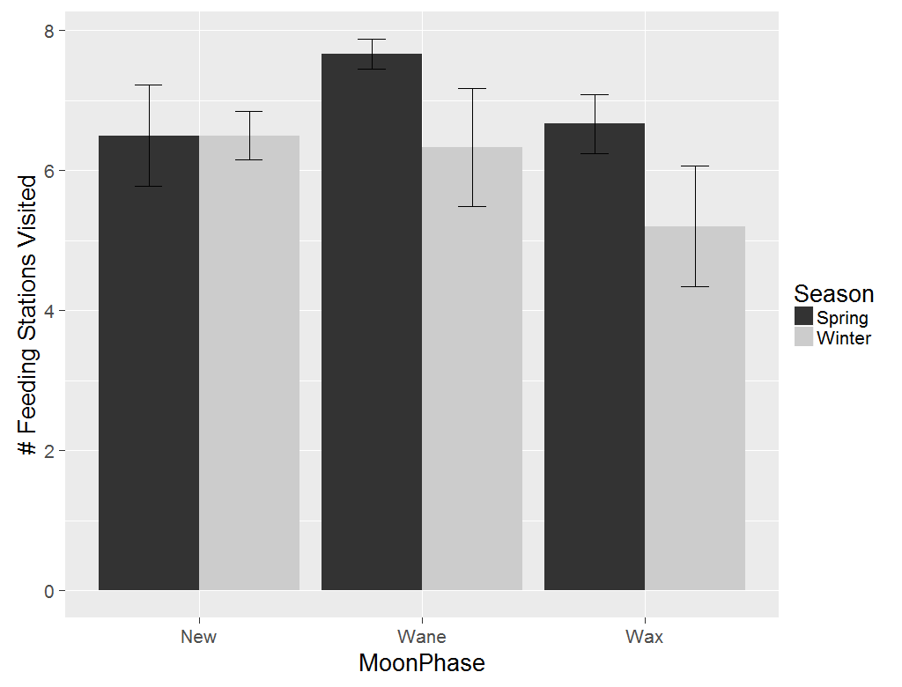

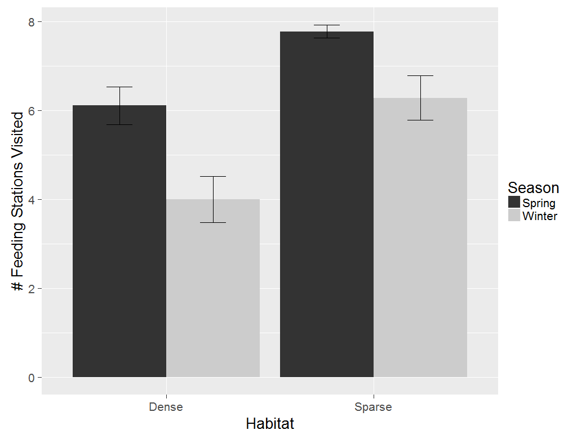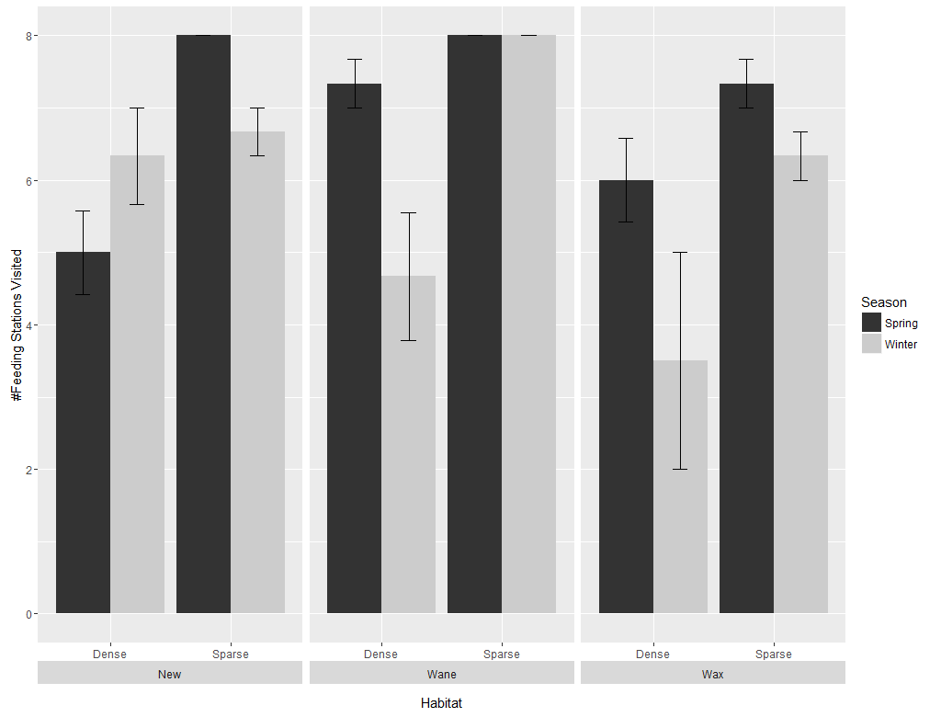

**Linear mixed effects model for #Feeding Stations visited**

Response variable squared to correct for heteroscedasticity

|  |
| --- |
| Analysis of Deviance Table (Type II Wald chisquare tests)  Response: (Visited^2)  Chisq Df Pr(>Chisq)  Habitat 44.8177 1 2.163e-11 ***  season 9.0127 1 0.002681 **  moonPhase 4.6698 3 0.197638  Habitat:moonPhase 0.3488 3 0.950597  Habitat:season 0.0114 1 0.915095  Habitat:season:moonPhase 16.4756 4 0.002443 ** |

**ANOVA for #Feeding Stations visited**

|  |
| --- |
| Error: moonPhase  Df Sum Sq Mean Sq  Habitat 1 2180 2180  season 1 4220 4220  moonPhase 1 338 338  Error: Within  Df Sum Sq Mean Sq F value Pr(>F)  Habitat 1 5480 5480 43.754 1.85e-07 ***  season 1 1142 1142 9.116 0.00495 **  Habitat:moonPhase 3 43 14 0.114 0.95140  Habitat:season 1 1 1 0.011 0.91576  Habitat:season:moonPhase 4 2064 516 4.119 0.00837 **  Residuals 32 4008 125 |

**Activity**

**Linear mixed effects model for activity**

Analysis of Deviance Table (Type II Wald chisquare tests)

Response: meanCrossings

Chisq Df Pr(>Chisq)

moonPhase 95.2122 3 < 2.2e-16 ***

habitat 15.1068 1 0.0001016 ***

FeedingTrayPosition 11.5550 1 0.0006757 ***

season 10.4722 1 0.0012119 **

moonPhase:habitat 14.4898 3 0.0023089 **

moonPhase:season 14.7981 2 0.0006118 ***

habitat:FeedingTrayPosition 4.3177 1 0.0377171 *

moonPhase:FeedingTrayPosition 3.2615 3 0.3530380

habitat:season 0.4580 1 0.4985674

moonPhase:habitat:FeedingTrayPosition 0.0794 3 0.9941924

moonPhase:habitat:season 0.6398 2 0.7262159

**ANOVA for activity**

Error: fStn

Df Sum Sq Mean Sq F value Pr(>F)

habitat 1 792.2 792.2 15.11 0.00164 **

Residuals 14 734.1 52.4

---

Signif. codes: 0 ‘***’ 0.001 ‘**’ 0.01 ‘*’ 0.05 ‘.’ 0.1 ‘ ’ 1

Error: Within

Df Sum Sq Mean Sq F value Pr(>F)

moonPhase 3 526.6 175.55 45.927 < 2e-16 ***

FeedingTrayPosition 1 44.2 44.17 11.555 0.000802 ***

season 1 40.0 40.03 10.472 0.001399 **

moonPhase:habitat 3 76.6 25.54 6.680 0.000246 ***

moonPhase:season 2 56.6 28.28 7.399 0.000776 ***

habitat:FeedingTrayPosition 1 16.5 16.50 4.318 0.038877 *

moonPhase:FeedingTrayPosition 3 12.5 4.16 1.087 0.355387

habitat:season 1 1.8 1.75 0.458 0.499278

moonPhase:habitat:FeedingTrayPosition 3 0.3 0.10 0.026 0.994174

moonPhase:habitat:season 2 2.4 1.22 0.320 0.726553

post-hoc analysis of moonphase*season interaction

|  |
| --- |
| *between moon phases* |
| contrast estimate SE df t.ratio p.value |
| New,Spring - Wane,Spring -0.64986541 0.1256536 234 -5.172 <.0001*  New,Spring - Wax,Spring -0.04869545 0.1256536 234 -0.388 0.9999  Wane,Spring - Wax,Spring 0.60116996 0.1256536 234 4.784 0.0001* |
|  |
|  |
| Full,Winter - New,Winter -0.78651986 0.1088192 234 -7.228 <.0001*  Full,Winter - Wane,Winter -0.83897928 0.1088192 234 -7.710 <.0001*  Full,Winter - Wax,Winter -0.40194559 0.1088192 234 -3.694 0.0066*  New,Winter - Wane,Winter -0.05245942 0.1256536 234 -0.417 0.9999  New,Winter - Wax,Winter 0.38457427 0.1256536 234 3.061 0.0497*  Wane,Winter - Wax,Winter 0.43703370 0.1256536 234 3.478 0.0138* |
|  |
|  |
|  |
| *between seasons* |
|  |
| New,Spring - New,Winter -0.07641495 0.1256536 234 -0.608 0.9988 |
| Wane,Spring - Wane,Winter 0.52099104 0.1256536 234 4.146 0.0012* |
| Wax,Spring - Wax,Winter 0.35685478 0.1256536 234 2.840 0.0903. |
|  |

post-hoc analysis of habitat*feedingTrayPosition interaction

|  |
| --- |
| contrast estimate SE df t.ratio p.value |
| *Between habitat* |
| Dense,F - Sparse,F -0.8041896 0.2016350 20.13 -3.988 0.0037*  Dense,N - Sparse,N -0.8669050 0.2016350 20.13 -4.299 0.0018* |
| *Between microhabitat* |
| Dense,F - Dense,N -0.1678919 0.1165245 238.00 -1.441 0.4752  Sparse,F - Sparse,N -0.2306072 0.1165245 238.00 -1.979 0.1988 |

post-hoc analysis of moonphase*habitat interaction

|  |
| --- |
| *within habitat, between moon phase* |
|  |
| *contrast estimate SE df t.ratio p.value* |
| Full,Dense - New,Dense -0.606833439 0.1312518 234.00 -4.623 0.0002* |
| Full,Dense - Wane,Dense -0.972783318 0.1312518 234.00 -7.412 <.0001* |
| Full,Dense - Wax,Dense -0.409948041 0.1312518 234.00 -3.123 0.0415 |
| New,Dense - Wane,Dense -0.365949879 0.1312518 234.00 -2.788 0.1030  New,Dense - Wax,Dense 0.196885398 0.1312518 234.00 1.500 0.8069 |
| Wane,Dense - Wax,Dense 0.562835277 0.1312518 234.00 4.288 0.0007* |
|  |
| Full,Sparse - New,Sparse -0.889791336 0.1312518 234.00 -6.779 <.0001*  Full,Sparse - Wane,Sparse -1.226166292 0.1312518 234.00 -9.342 <.0001*  Full,Sparse - Wax,Sparse -0.750797913 0.1312518 234.00 -5.720 <.0001*  New,Sparse - Wane,Sparse -0.336374955 0.1312518 234.00 -2.563 0.1751  New,Sparse - Wax,Sparse 0.138993423 0.1312518 234.00 1.059 0.9644  Wane,Sparse - Wax,Sparse 0.475368379 0.1312518 234.00 3.622 0.0085* |
|  |
|  |
| *Within moonphase, between habitat* |
| Full,Dense - Full,Sparse -0.616249637 0.2163052 26.49 -2.849 0.1250 |
| New,Dense - New,Sparse -0.899207535 0.2163052 26.49 -4.157 0.0063* |
| Wane,Dense - Wane,Sparse -0.869632611 0.2163052 26.49 -4.020 0.0088* |
| Wax,Dense - Wax,Sparse -0.957099509 0.2163052 26.49 -4.425 0.0032* |

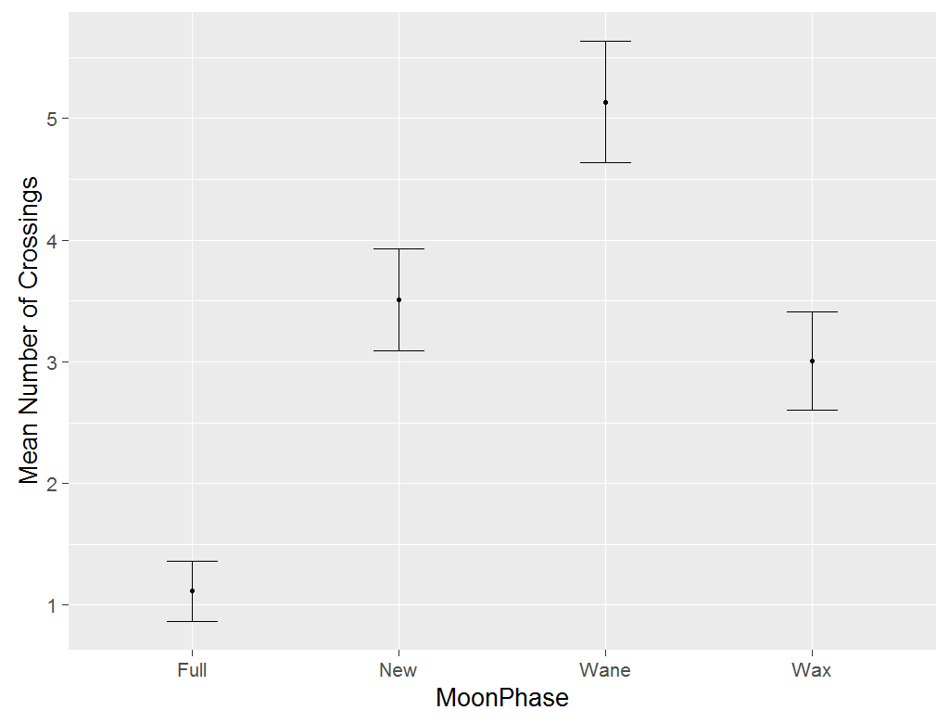 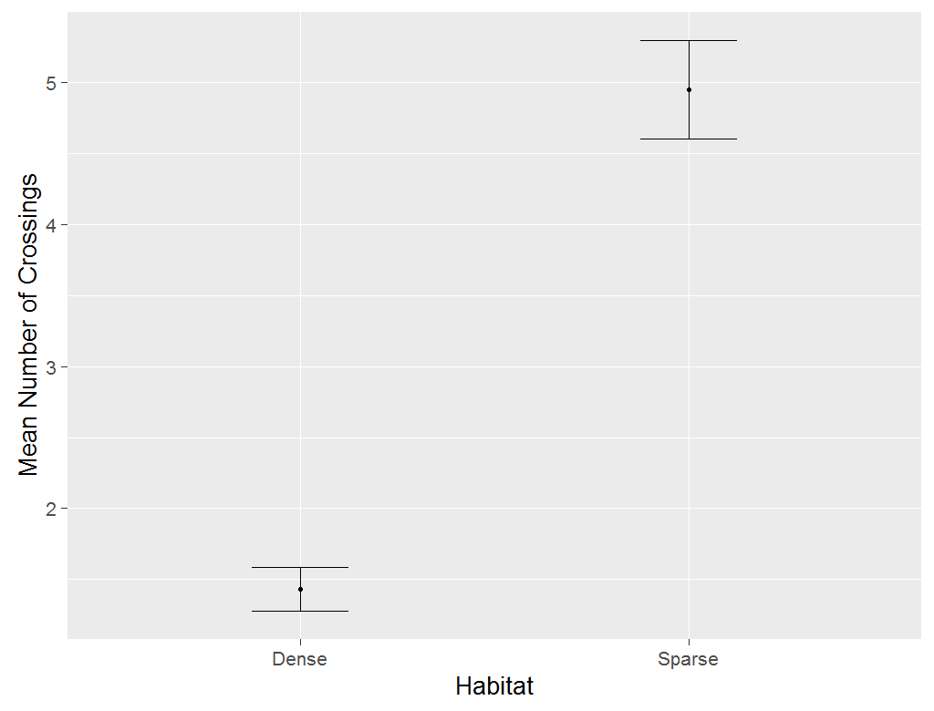

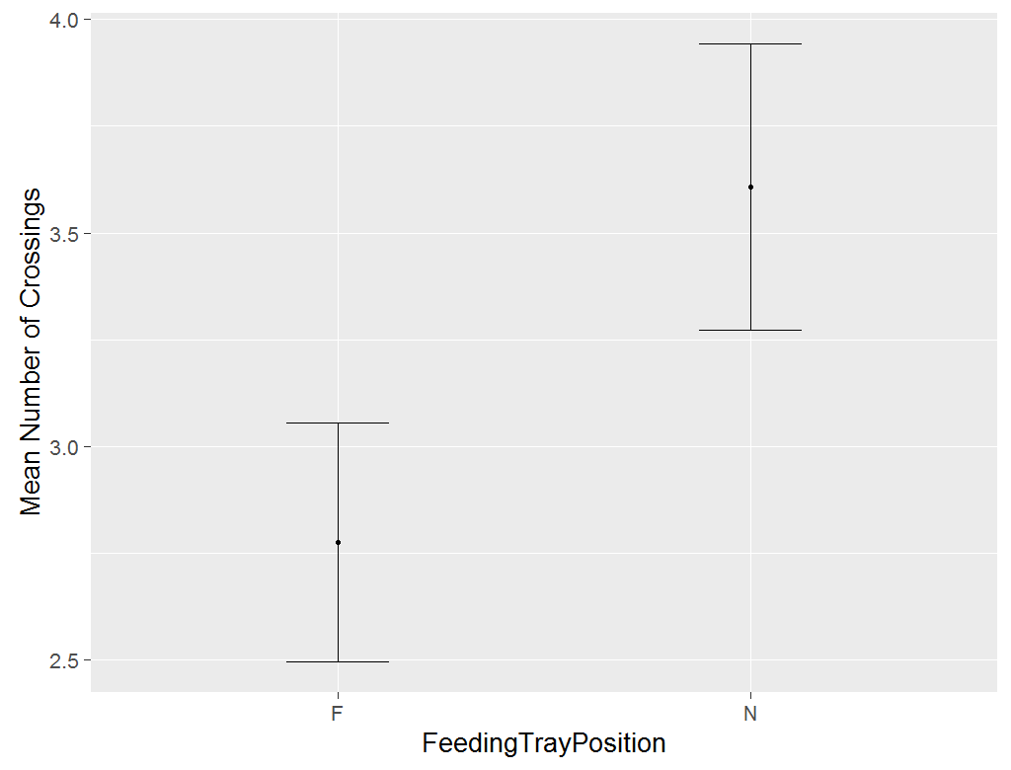 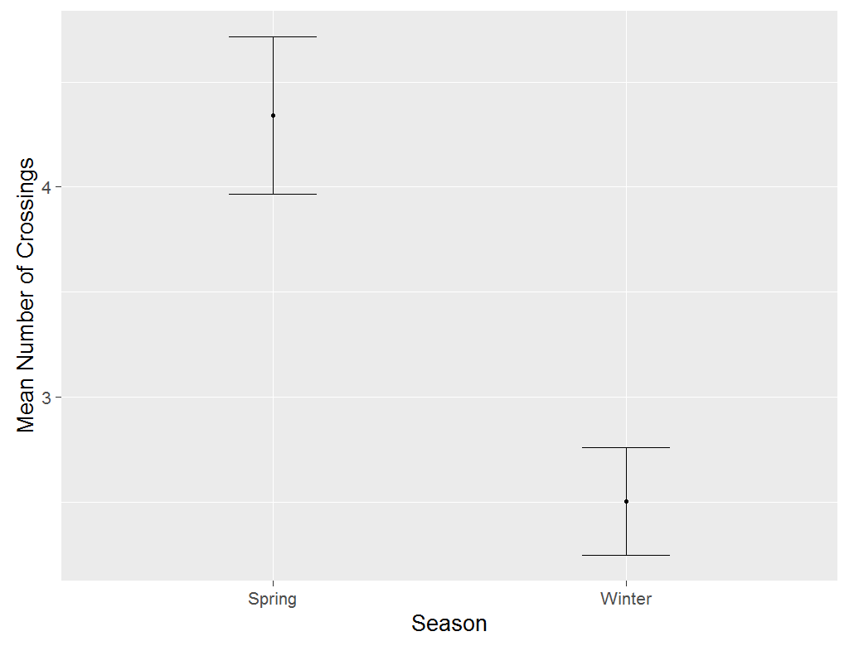

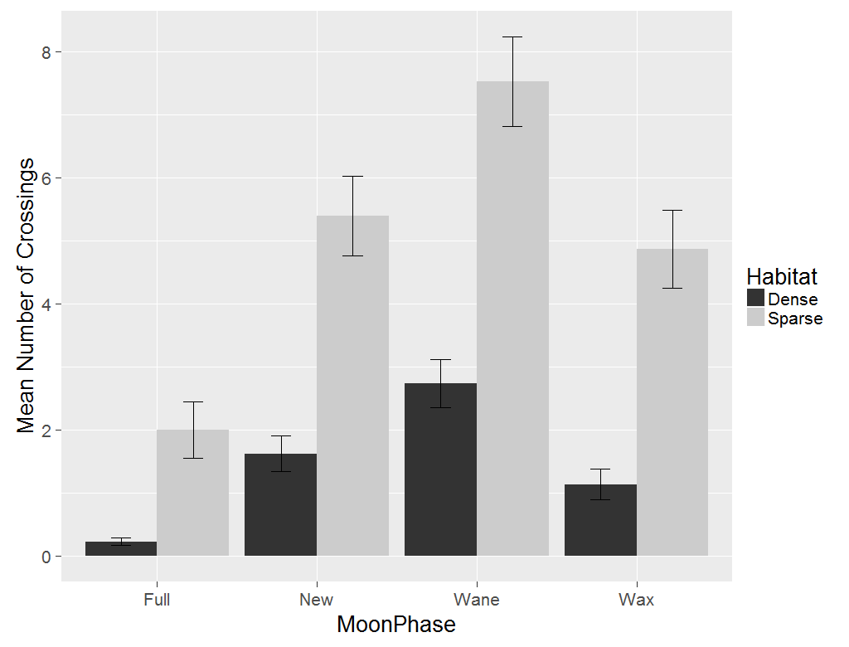

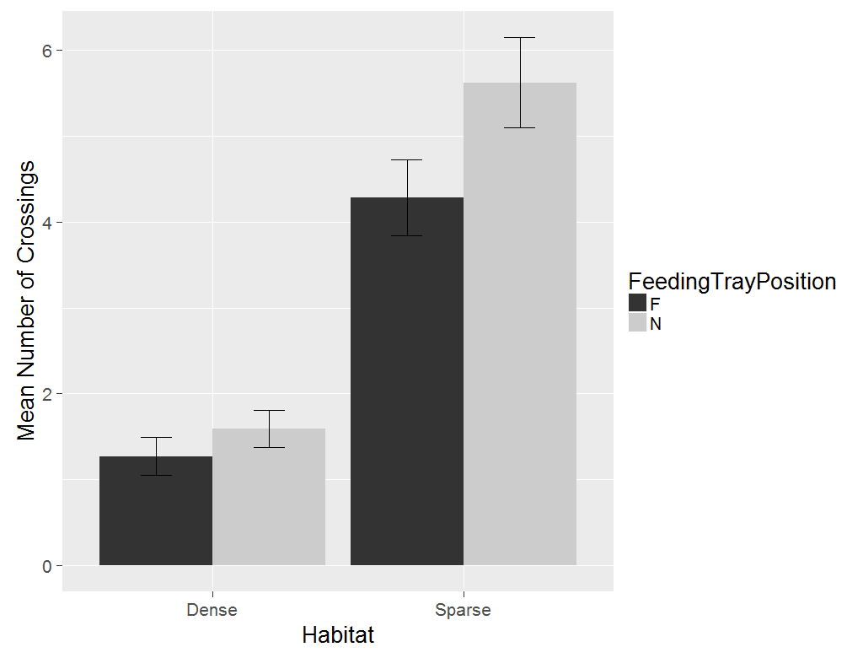 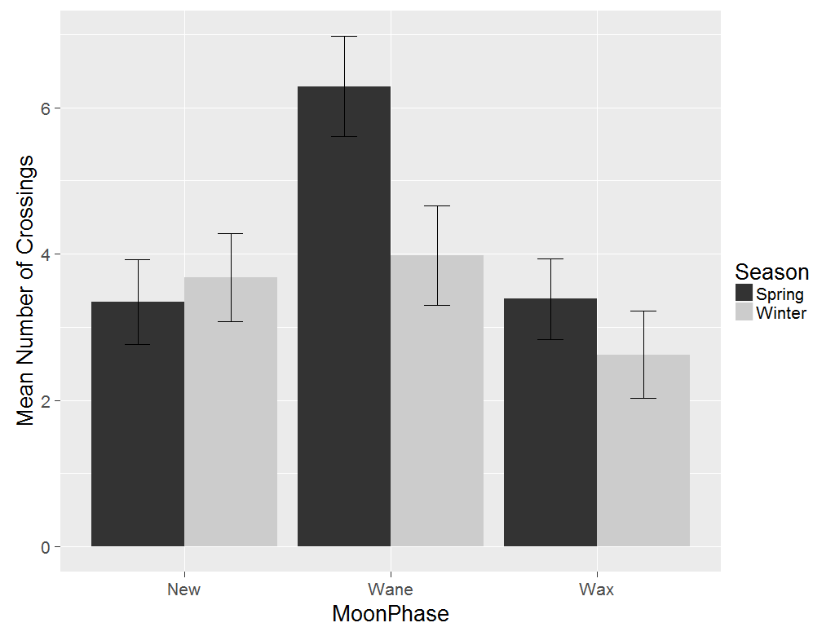

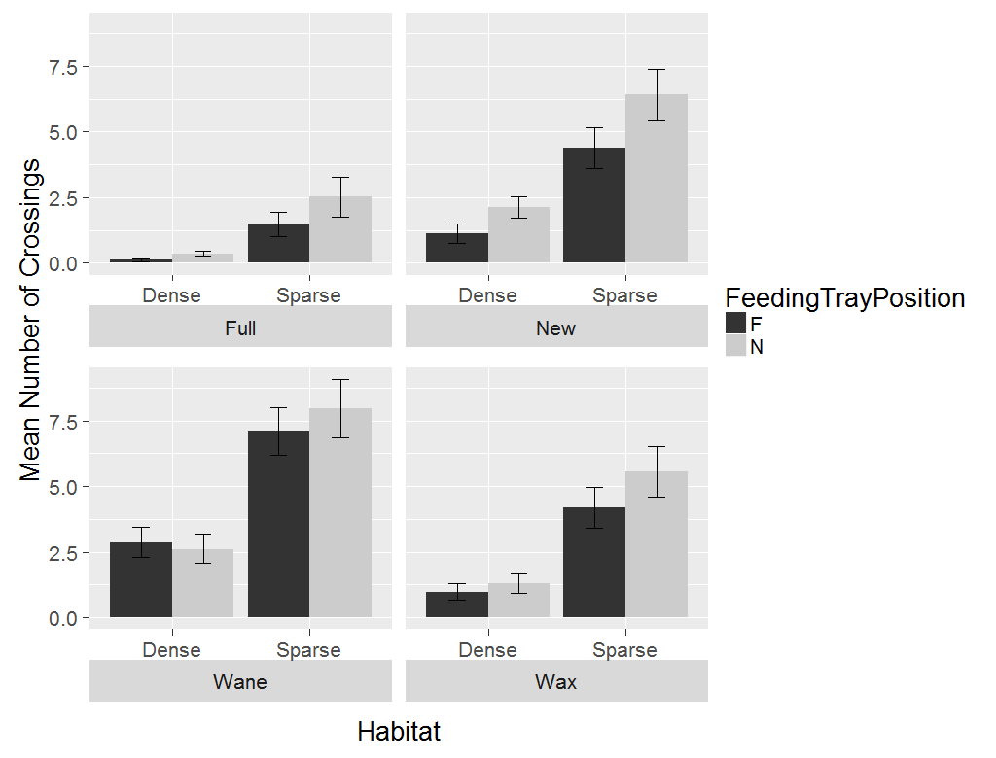

**Full moon phase dropped**

LMM

|  |
| --- |
| Analysis of Deviance Table (Type II Wald chisquare tests)  Response: (meanCrossings)  Chisq Df Pr(>Chisq)  moonPhase 41.8205 2 8.295e-10 ***  habitat 14.5354 1 0.0001376 ***  FeedingTrayPosition 10.0798 1 0.0014991 **  season 10.5559 1 0.0011582 **  moonPhase:habitat 3.0238 2 0.2204877  moonPhase:season 14.9165 2 0.0005767 ***  habitat:FeedingTrayPosition 3.7617 1 0.0524393 .  moonPhase:FeedingTrayPosition 3.0952 2 0.2127529  habitat:season 0.4616 1 0.4968552  moonPhase:habitat:FeedingTrayPosition 0.0095 2 0.9952802  moonPhase:habitat:season 0.6449 2 0.7243604 |

ANOVA for activity with full moon phase dropped

|  |
| --- |
| Error: fStn  Df Sum Sq Mean Sq F value Pr(>F)  habitat 1 807.2 807.2 14.54 0.0019 **  Residuals 14 777.4 55.5  ---  Signif. codes: 0 ‘***’ 0.001 ‘**’ 0.01 ‘*’ 0.05 ‘.’ 0.1 ‘ ’ 1  Error: Within  Df Sum Sq Mean Sq F value Pr(>F)  moonPhase 2 158.6 79.29 20.910 8.56e-09 ***  FeedingTrayPosition 1 38.2 38.22 10.080 0.00180 **  season 1 40.0 40.03 10.556 0.00141 **  moonPhase:habitat 2 11.5 5.73 1.512 0.22362  moonPhase:season 2 56.6 28.28 7.458 0.00080 ***  habitat:FeedingTrayPosition 1 14.3 14.26 3.762 0.05420 .  moonPhase:FeedingTrayPosition 2 11.7 5.87 1.548 0.21592  habitat:season 1 1.8 1.75 0.462 0.49784  moonPhase:habitat:FeedingTrayPosition 2 0.0 0.02 0.005 0.99528  moonPhase:habitat:season 2 2.4 1.22 0.322 0.72483  Residuals 160 606.7 3.79 |

Post-hoc analysis of habitat*feedingTrayPosition

|  |
| --- |
| contrast estimate SE df t.ratio p.value |
| Dense,F - Sparse,F -3.5555556 1.123995 16.68 -3.163 0.0268  Dense,F - Dense,N -0.3472222 0.461480 174.00 -0.752 0.8755  Sparse,F - Sparse,N -1.4375000 0.461480 174.00 -3.115 0.0115*  Dense,N - Sparse,N -4.6458333 1.123995 16.68 -4.133 0.0036* |

Post-hoc analysis of moonPhase*season

|  |
| --- |
| contrast estimate SE df t.ratio p.value |
| *Within moon phase, between season*  New,Spring - New,Winter -0.33333333 0.5009667 171 -0.665 0.9854  Wane,Spring - Wane,Winter 2.31250000 0.5009667 171 4.616 0.0001*  Wax,Spring - Wax,Winter 0.76041667 0.5009667 171 1.518 0.6533  *Within Season, between moon phase*  New,Winter - Wane,Winter -0.30208333 0.5009667 171 -0.603 0.9907  New,Winter - Wax,Winter 1.05208333 0.5009667 171 2.100 0.2922  Wane,Winter - Wax,Winter 1.35416667 0.5009667 171 2.703 0.0799*  New,Spring - Wane,Spring -2.94791667 0.5009667 171 -5.884 <.0001*  New,Spring - Wax,Spring -0.04166667 0.5009667 171 -0.083 1.0000  Wane,Spring - Wax,Spring 2.90625000 0.5009667 171 5.801 <.0001* |



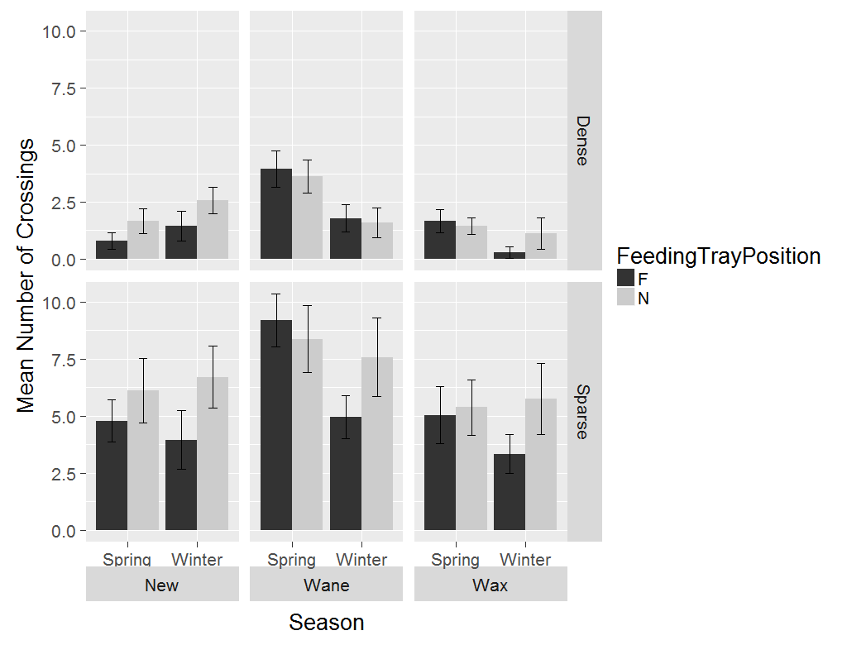

**GUDs**

**Linear mixed effects model for GUDs**

Response: meanGUD

Chisq Df Pr(>Chisq)

moonPhase 2.6108 3 0.4556001

habitat 6.6658 1 0.0098282 **

FeedingTrayPosition 0.5521 1 0.4574806

season 11.2845 1 0.0007816 ***

moonPhase:habitat 1.3913 3 0.7075786

moonPhase:FeedingTrayPosition 0.3220 3 0.9558436

moonPhase:season 0.0944 2 0.9539166

habitat:FeedingTrayPosition 0.3263 1 0.5678583

habitat:season 4.8739 1 0.0272657 *

moonPhase:habitat:FeedingTrayPosition 0.9678 3 0.8090437

moonPhase:habitat:season 1.5080 2 0.4704733

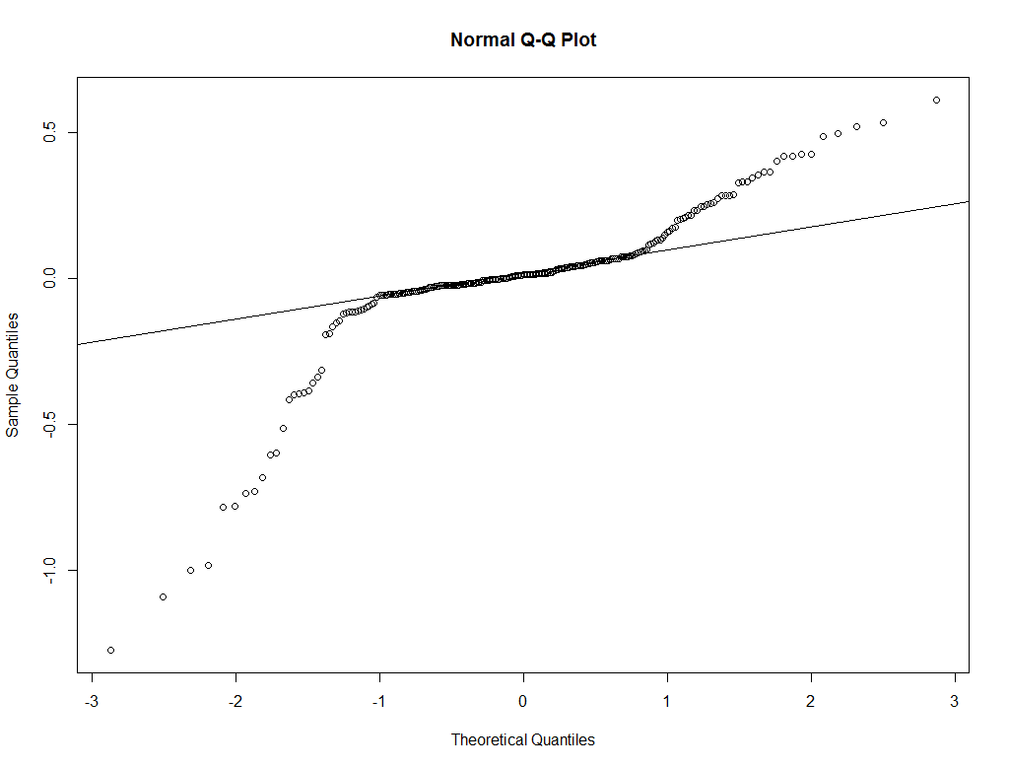

Residuals indicate non-normality of data

**ANOVA with no transformation**

Error: fStn

Df Sum Sq Mean Sq F value Pr(>F)

moonPhase 3 9.707 3.236 116.339 6.15e-07 ***

habitat 1 0.789 0.789 28.355 0.000707 ***

FeedingTrayPosition 1 0.168 0.168 6.049 0.039346 *

season 1 0.078 0.078 2.794 0.133132

moonPhase:habitat 1 1.393 1.393 50.082 0.000104 ***

Residuals 8 0.223 0.028

---

Signif. codes: 0 ‘***’ 0.001 ‘**’ 0.01 ‘*’ 0.05 ‘.’ 0.1 ‘ ’ 1

Error: Within

Df Sum Sq Mean Sq F value Pr(>F)

moonPhase 3 0.523 0.1744 2.468 0.063174 .

FeedingTrayPosition 1 0.055 0.0551 0.780 0.378102

season 1 0.814 0.8137 11.516 0.000827 ***

moonPhase:habitat 3 0.261 0.0870 1.231 0.299304

moonPhase:FeedingTrayPosition 3 0.022 0.0074 0.105 0.957113

moonPhase:season 2 0.008 0.0040 0.056 0.945259

habitat:FeedingTrayPosition 1 0.029 0.0289 0.409 0.522981

habitat:season 1 0.344 0.3443 4.873 0.028373 *

moonPhase:habitat:FeedingTrayPosition 3 0.069 0.0229 0.325 0.807487

moonPhase:habitat:season 2 0.096 0.0482 0.683 0.506419

Residuals 207 14.626 0.0707

ANOVA with log-transformed response, without Error term for feeding station

Df Sum Sq Mean Sq F value Pr(>F)

moonPhase 3 0.098 0.0327 1.453 0.22829

habitat 1 0.676 0.6759 30.076 1.13e-07 ***

FeedingTrayPosition 1 0.001 0.0015 0.065 0.79879

season 1 0.158 0.1575 7.011 0.00869 **

moonPhase:habitat 3 0.058 0.0192 0.855 0.46529

moonPhase:season 2 0.003 0.0015 0.068 0.93433

moonPhase:FeedingTrayPosition 3 0.007 0.0022 0.099 0.96046

habitat:FeedingTrayPosition 1 0.000 0.0001 0.005 0.94531

habitat:season 1 0.079 0.0792 3.526 0.06174 .

moonPhase:habitat:FeedingTrayPosition 3 0.011 0.0038 0.168 0.91768

moonPhase:habitat:season 2 0.038 0.0188 0.836 0.43498

Residuals 221 4.966 0.0225

**----------------------------**

ANOVA with arcsin-transformed response (converted to proportion), without Error term for feeding station

Here, response is asin(GUD/3)

Df Sum Sq Mean Sq F value Pr(>F)

moonPhase 3 0.402 0.134 2.474 0.06244 .

habitat 1 4.525 4.525 83.568 < 2e-16 ***

FeedingTrayPosition 1 0.012 0.012 0.214 0.64430

season 1 0.523 0.523 9.659 0.00213 **

moonPhase:habitat 3 0.082 0.027 0.506 0.67877

moonPhase:season 2 0.001 0.001 0.013 0.98747

moonPhase:FeedingTrayPosition 3 0.018 0.006 0.109 0.95465

habitat:FeedingTrayPosition 1 0.007 0.007 0.128 0.72066

habitat:season 1 0.066 0.066 1.210 0.27247

moonPhase:habitat:FeedingTrayPosition 3 0.082 0.027 0.506 0.67852

moonPhase:habitat:season 2 0.154 0.077 1.423 0.24321

Residuals 221 11.967 0.054

-------------------

ANOVA with log-transformed response with Error term for feeding station

Error: fStn

Df Sum Sq Mean Sq F value Pr(>F)

moonPhase 3 1.8739 0.6246 170.470 1.38e-07 ***

habitat 1 0.1206 0.1206 32.915 0.000435 ***

FeedingTrayPosition 1 0.0224 0.0224 6.108 0.038625 *

season 1 0.0234 0.0234 6.399 0.035274 *

moonPhase:habitat 1 0.2787 0.2787 76.073 2.33e-05 ***

Residuals 8 0.0293 0.0037

---

Signif. codes: 0 ‘***’ 0.001 ‘**’ 0.01 ‘*’ 0.05 ‘.’ 0.1 ‘ ’ 1

Error: Within

Df Sum Sq Mean Sq F value Pr(>F)

moonPhase 3 0.096 0.03188 2.009 0.11383

FeedingTrayPosition 1 0.006 0.00614 0.387 0.53475

season 1 0.176 0.17641 11.117 0.00101 **

moonPhase:habitat 3 0.054 0.01805 1.137 0.33502

moonPhase:season 2 0.002 0.00124 0.078 0.92498

moonPhase:FeedingTrayPosition 3 0.006 0.00213 0.134 0.93964

habitat:FeedingTrayPosition 1 0.003 0.00252 0.159 0.69080

habitat:season 1 0.090 0.08959 5.646 0.01841 *

moonPhase:habitat:FeedingTrayPosition 3 0.010 0.00349 0.220 0.88260

moonPhase:habitat:season 2 0.018 0.00889 0.560 0.57183

Residuals 207 3.285 0.01587

**-------------------------------------------**

ANOVA with arcsin-transformed response with Error term for feeding station

Error: fStn

Df Sum Sq Mean Sq F value Pr(>F)

moonPhase 3 6.323 2.1076 26.404 0.000168 ***

habitat 1 1.698 1.6980 21.272 0.001728 **

FeedingTrayPosition 1 0.212 0.2117 2.652 0.142041

season 1 0.004 0.0039 0.049 0.831001

moonPhase:habitat 1 0.828 0.8281 10.375 0.012221 *

Residuals 8 0.639 0.0798

---

Signif. codes: 0 ‘***’ 0.001 ‘**’ 0.01 ‘*’ 0.05 ‘.’ 0.1 ‘ ’ 1

Error: Within

Df Sum Sq Mean Sq F value Pr(>F)

moonPhase 3 0.419 0.1396 4.288 0.00583 **

FeedingTrayPosition 1 0.031 0.0308 0.946 0.33183

season 1 0.577 0.5772 17.724 3.81e-05 ***

moonPhase:habitat 3 0.080 0.0267 0.819 0.48471

moonPhase:season 2 0.021 0.0106 0.326 0.72228

moonPhase:FeedingTrayPosition 3 0.013 0.0044 0.135 0.93903

habitat:FeedingTrayPosition 1 0.023 0.0228 0.701 0.40342

habitat:season 1 0.077 0.0769 2.362 0.12581

moonPhase:habitat:FeedingTrayPosition 3 0.064 0.0212 0.652 0.58277

moonPhase:habitat:season 2 0.089 0.0445 1.365 0.25755

Residuals 207 6.741 0.0326

Post-hoc analysis of habitat:season interaction

|  |
| --- |
| *Between habitat*  contrast estimate SE df t.ratio p.value  Dense,Spring - Sparse,Spring 0.38759028 0.11170849 19.85 3.470 0.0120*  Dense,Winter - Sparse,Winter 0.19599045 0.10527299 15.70 1.862 0.2832  *Between season*  Dense,Spring - Dense,Winter -0.04976854 0.04889903 225.30 -1.018 0.7392  Sparse,Spring - Sparse,Winter -0.24136837 0.04976290 225.42 -4.850 <.0001* |

**Full moon phase dropped**

**LMM**

Analysis of Deviance Table (Type II Wald chisquare tests)

Response: asin(meanGUD/3)

Chisq Df Pr(>Chisq)

moonPhase 5.5129 2 0.063516 .

habitat 9.6026 1 0.001943 **

FeedingTrayPosition 0.6763 1 0.410855

season 19.9315 1 8.027e-06 ***

moonPhase:habitat 1.1293 2 0.568569

moonPhase:FeedingTrayPosition 0.4538 2 0.796999

moonPhase:season 1.0470 2 0.592441

habitat:FeedingTrayPosition 0.7107 1 0.399209

habitat:season 2.8047 1 0.093990 .

moonPhase:habitat:FeedingTrayPosition 2.0594 2 0.357110

moonPhase:habitat:season 2.6259 2 0.269024

**ANOVA with no transformation**

Error: fStn

Df Sum Sq Mean Sq F value Pr(>F)

moonPhase 2 5.873 2.9367 36.662 4.72e-05 ***

habitat 1 1.558 1.5584 19.455 0.00169 **

FeedingTrayPosition 1 0.146 0.1456 1.818 0.21055

season 1 0.010 0.0103 0.129 0.72766

moonPhase:habitat 1 1.337 1.3369 16.691 0.00274 **

Residuals 9 0.721 0.0801

---

Signif. codes: 0 ‘***’ 0.001 ‘**’ 0.01 ‘*’ 0.05 ‘.’ 0.1 ‘ ’ 1

Error: Within

Df Sum Sq Mean Sq F value Pr(>F)

moonPhase 2 0.135 0.0673 2.261 0.1078

FeedingTrayPosition 1 0.027 0.0266 0.893 0.3461

season 1 0.604 0.6040 20.279 1.34e-05 ***

moonPhase:habitat 2 0.032 0.0161 0.539 0.5842

moonPhase:FeedingTrayPosition 2 0.013 0.0066 0.221 0.8022

moonPhase:season 2 0.034 0.0168 0.562 0.5711

habitat:FeedingTrayPosition 1 0.023 0.0225 0.757 0.3858

habitat:season 1 0.083 0.0829 2.784 0.0973 .

moonPhase:habitat:FeedingTrayPosition 2 0.062 0.0310 1.039 0.3563

moonPhase:habitat:season 2 0.073 0.0366 1.230 0.2952

Residuals 149 4.438 0.0298

Only ANOVA with arcsin-transformed response with Error term for feeding station was different from the model from which Full moon phase was not dropped:

Error: fStn

Df Sum Sq Mean Sq F value Pr(>F)

moonPhase 2 5.873 2.9367 36.662 4.72e-05 ***

habitat 1 1.558 1.5584 19.455 0.00169 **

FeedingTrayPosition 1 0.146 0.1456 1.818 0.21055

season 1 0.010 0.0103 0.129 0.72766

moonPhase:habitat 1 1.337 1.3369 16.691 0.00274 **

Residuals 9 0.721 0.0801

---

Signif. codes: 0 ‘***’ 0.001 ‘**’ 0.01 ‘*’ 0.05 ‘.’ 0.1 ‘ ’ 1

Error: Within

Df Sum Sq Mean Sq F value Pr(>F)

moonPhase 2 0.135 0.0673 2.261 0.1078

FeedingTrayPosition 1 0.027 0.0266 0.893 0.3461

season 1 0.604 0.6040 20.279 1.34e-05 ***

moonPhase:habitat 2 0.032 0.0161 0.539 0.5842

moonPhase:season 2 0.035 0.0174 0.584 0.5587

moonPhase:FeedingTrayPosition 2 0.012 0.0059 0.199 0.8201

habitat:FeedingTrayPosition 1 0.023 0.0225 0.757 0.3858

habitat:season 1 0.083 0.0829 2.784 0.0973 .

moonPhase:habitat:FeedingTrayPosition 2 0.062 0.0310 1.039 0.3563

moonPhase:habitat:season 2 0.073 0.0366 1.230 0.2952

Residuals 149 4.438 0.0298

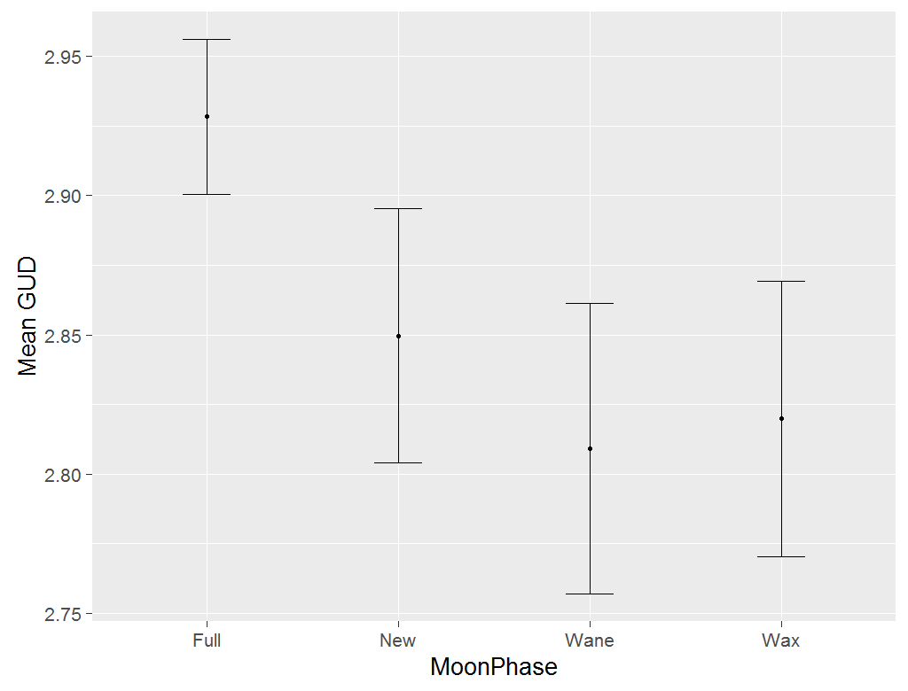 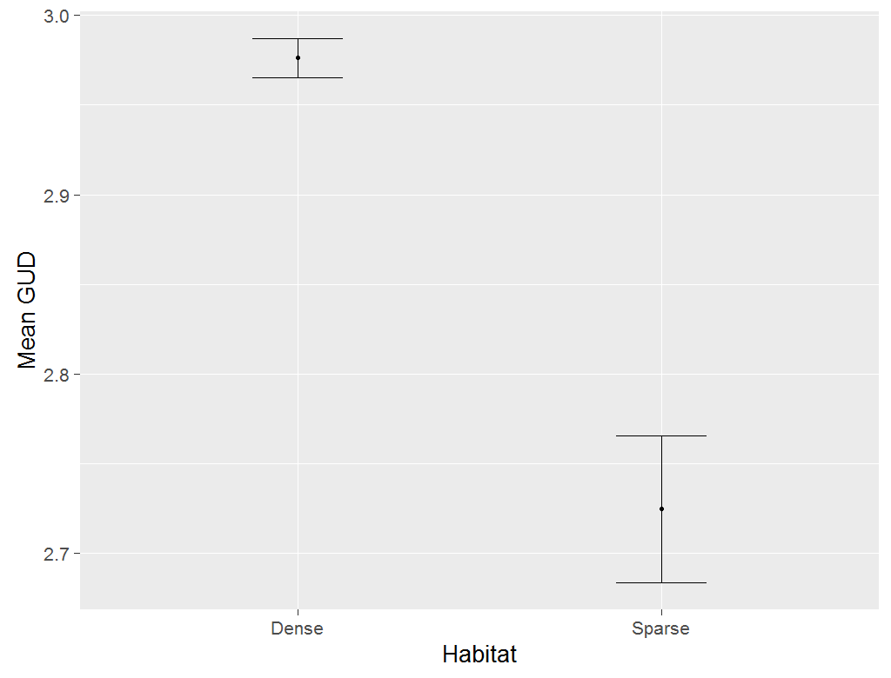

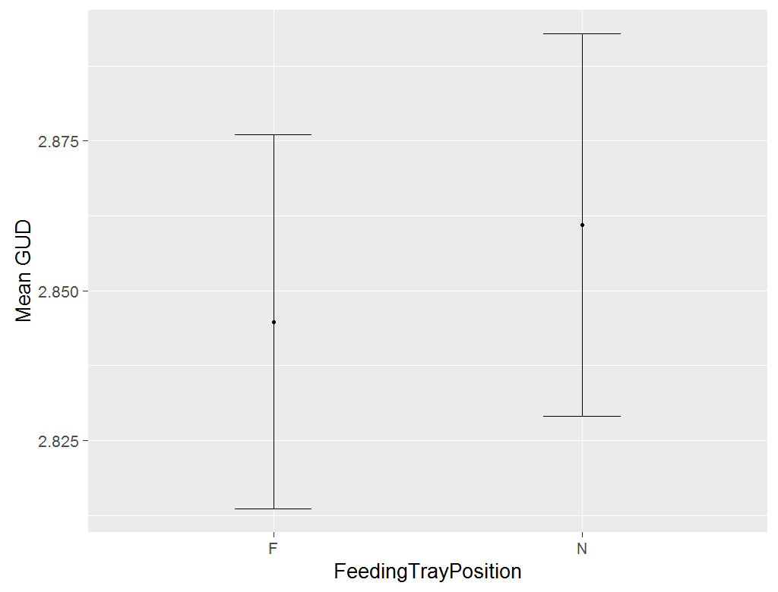 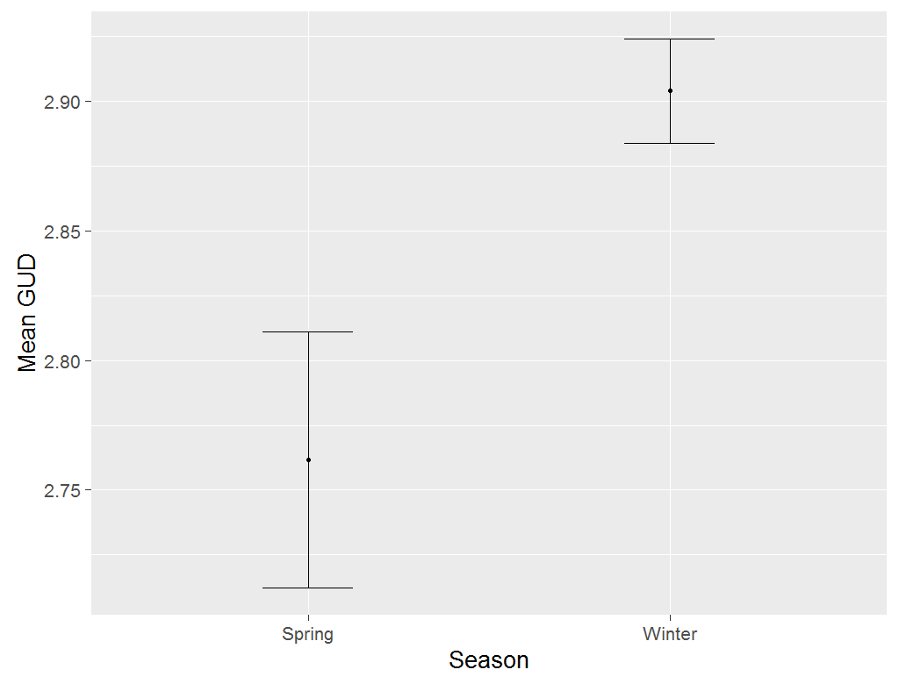

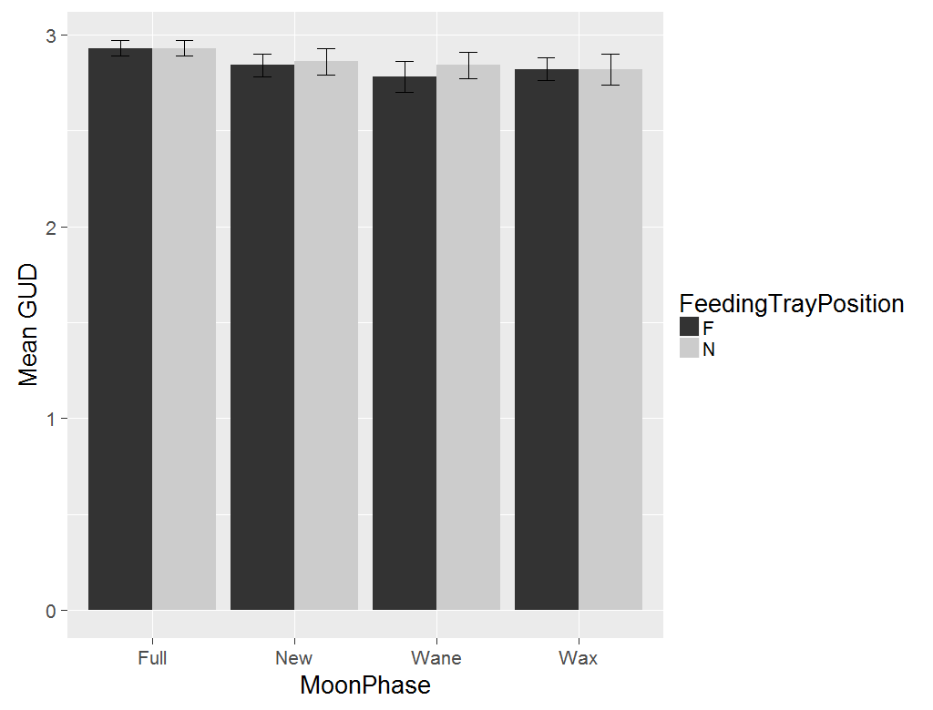 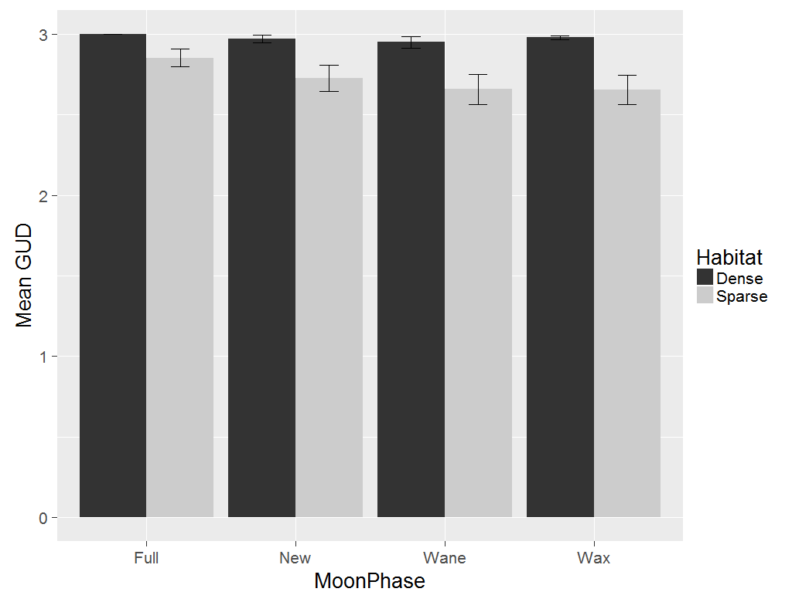

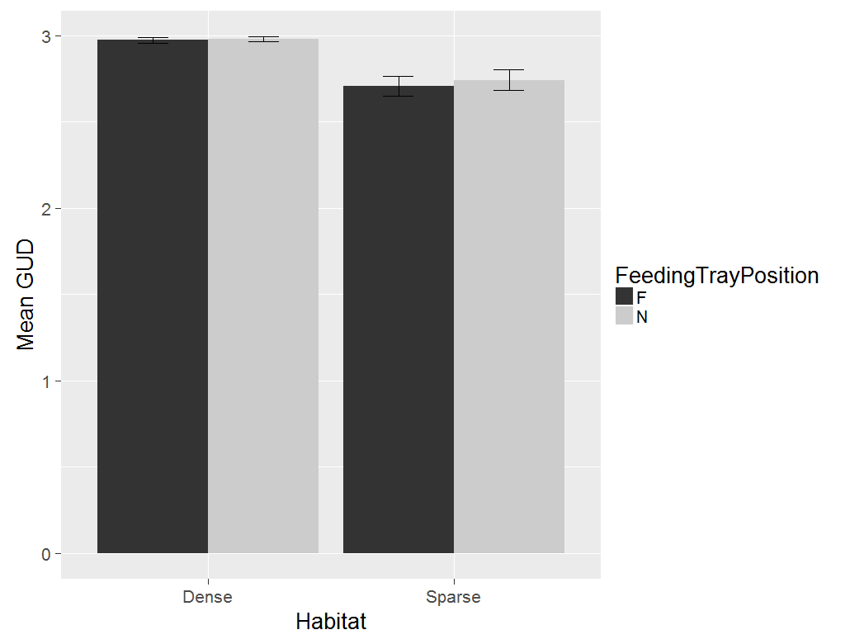 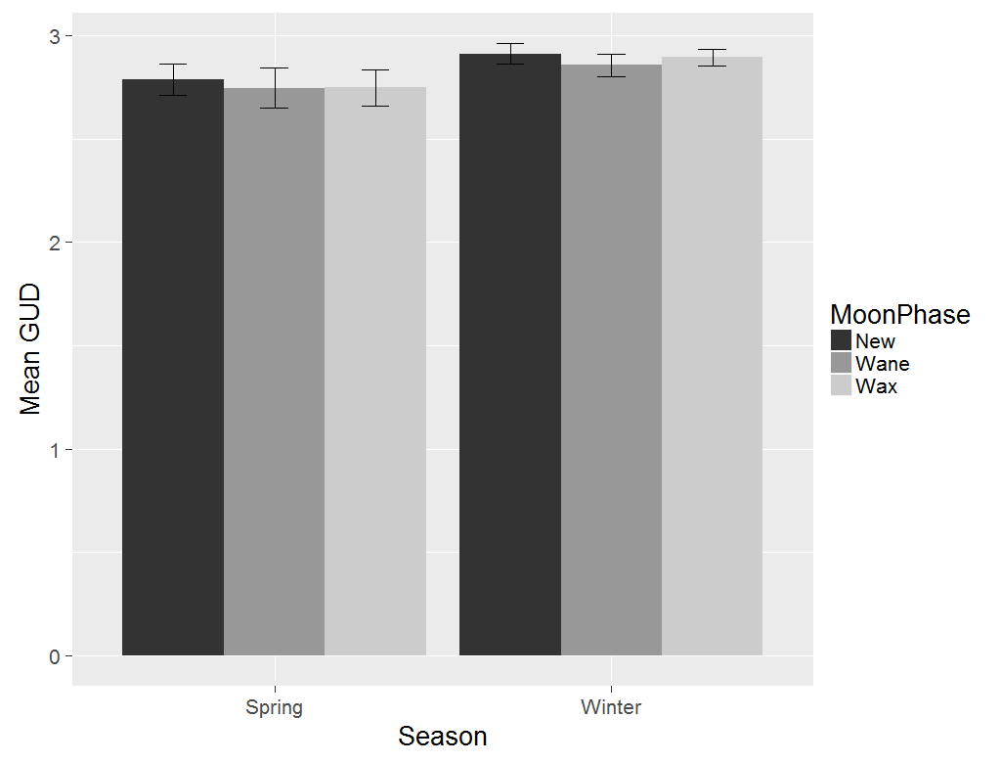

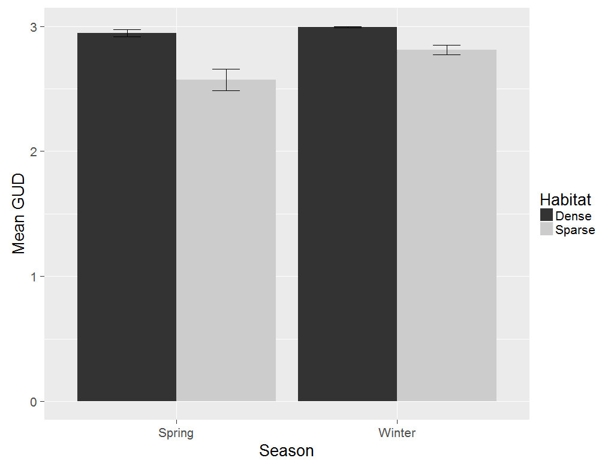

**Part 2.** *How does removal of Prosopis affect rodent behaviour?*

**Activity**

Mean taken for each feeding station across two days of control (tree not cut) and treatment (tree cut).

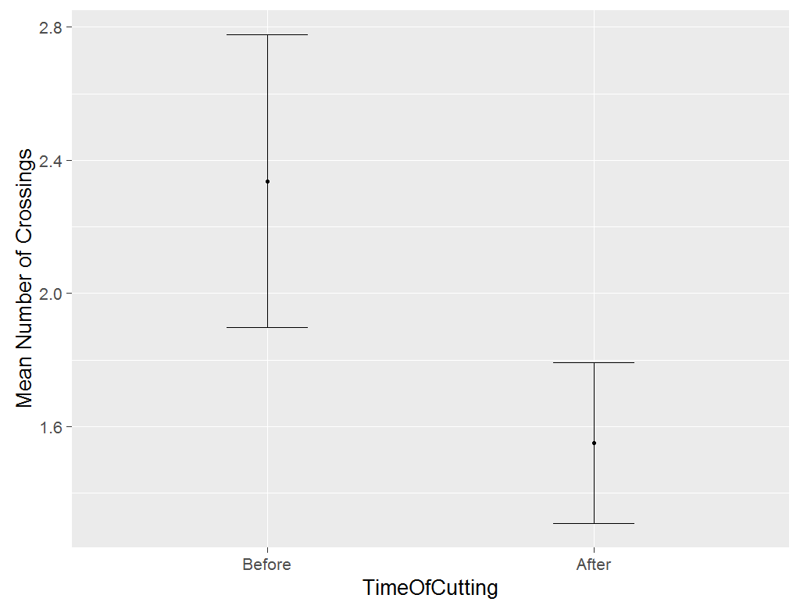 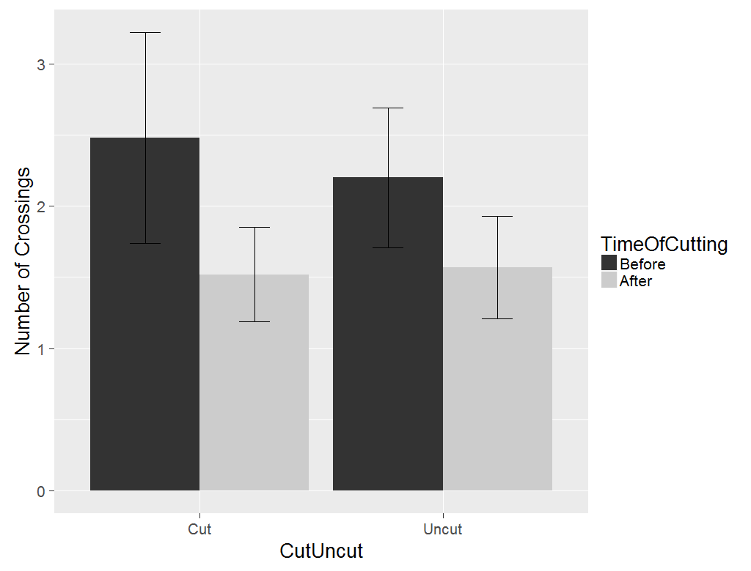

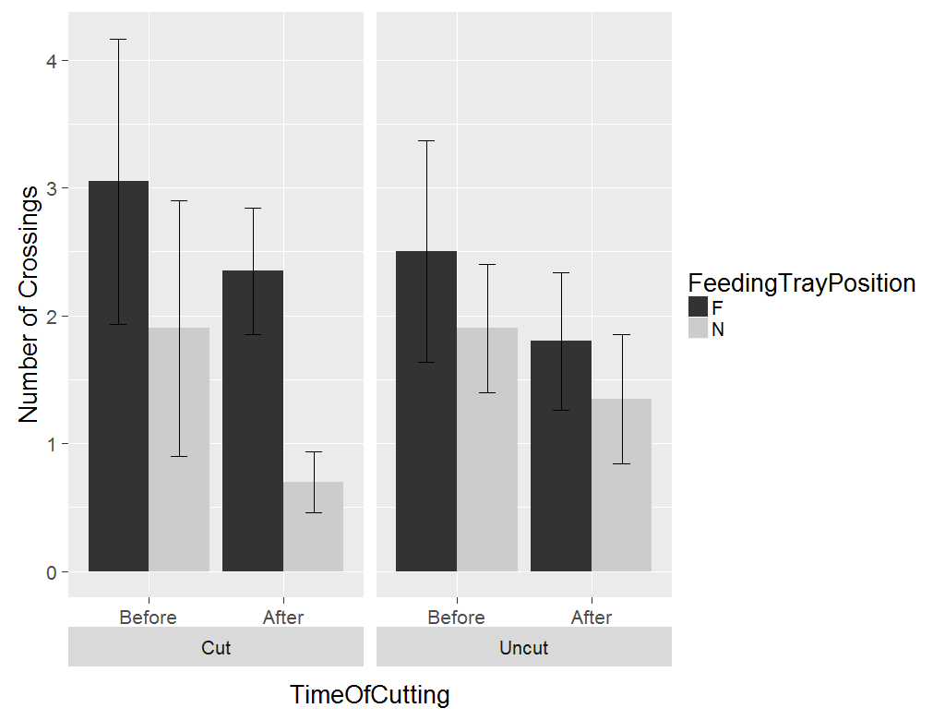

**Results of ANOVA with Error term for feeding station**

Error: fStn

Df Sum Sq Mean Sq F value Pr(>F)

cutUncut 1 0.000 0.00031 0.002 0.969

Residuals 18 3.559 0.19775

Error: Within

Df Sum Sq Mean Sq F value Pr(>F)

BefOnAft 1 0.1054 0.10545 2.582 0.1139

BefOnAft:cutUncut 1 0.0016 0.00160 0.039 0.8437

BefOnAft:cutUncut:FeedingTrayPosition 4 0.5902 0.14756 3.614 0.0111 *

Residuals 54 2.2051 0.04084

------------------------------------

**Results of linear mixed effects model**

Analysis of Deviance Table (Type II Wald chisquare tests)

Response: log10(meanCrossings + 1)

Chisq Df Pr(>Chisq)

BefOnAft 2.5822 1 0.108073

cutUncut 0.0016 1 0.968241

BefOnAft:cutUncut 0.0392 1 0.842982

BefOnAft:cutUncut:FeedingTrayPosition 14.4541 4 0.005978 **

---------------------------------------------------

Post-hoc test

contrast estimate SE df t.ratio p.value

After,Cut,F - Before,Cut,F -0.02347261 0.09037241 54.00 -0.260 0.9967

Before,Uncut,F - Before,Cut,F -0.06704547 0.12654140 41.86 -0.530 0.9689

After,Uncut,F - Before,Cut,F -0.12725147 0.12654140 41.86 -1.006 0.8028

Before,Cut,N - Before,Cut,F -0.19232526 0.09037241 54.00 -2.128 0.1842

After,Cut,N - Before,Cut,F -0.29617249 0.09037241 54.00 -3.277 0.0113*

Before,Uncut,N - Before,Cut,F -0.09946085 0.12654140 41.86 -0.786 0.8996

After,Uncut,N - Before,Cut,F -0.20237667 0.12654140 41.86 -1.599 0.4465

**GUDs**

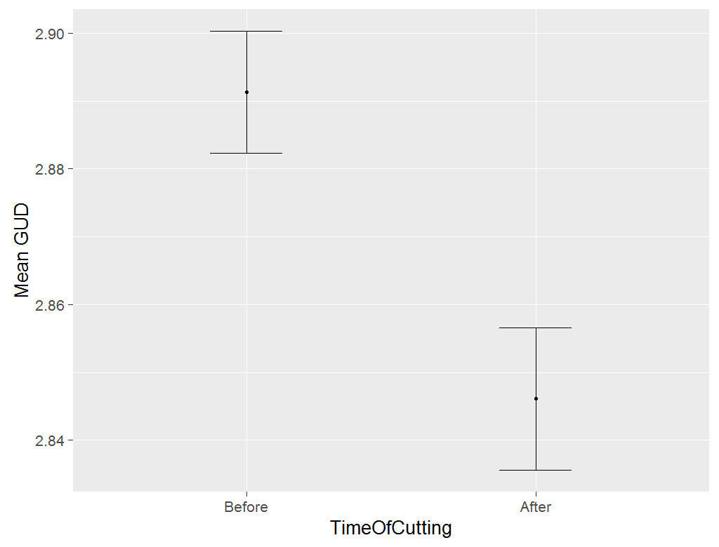 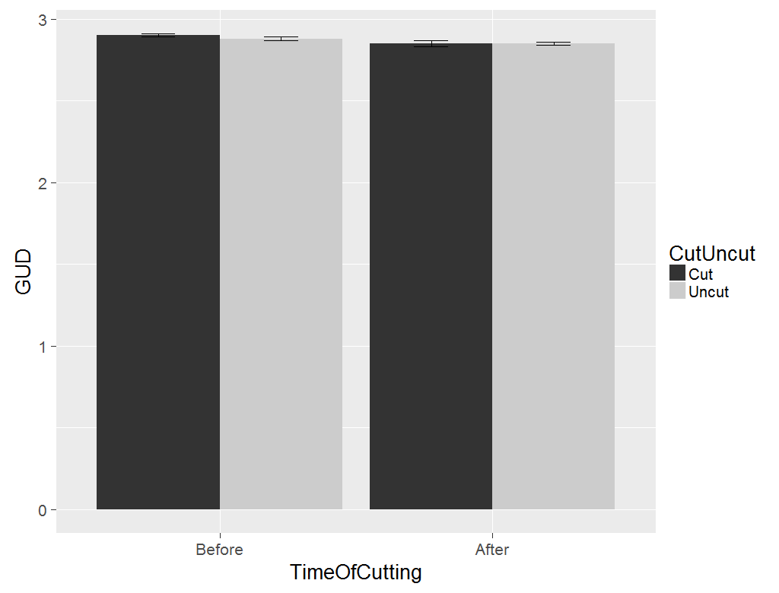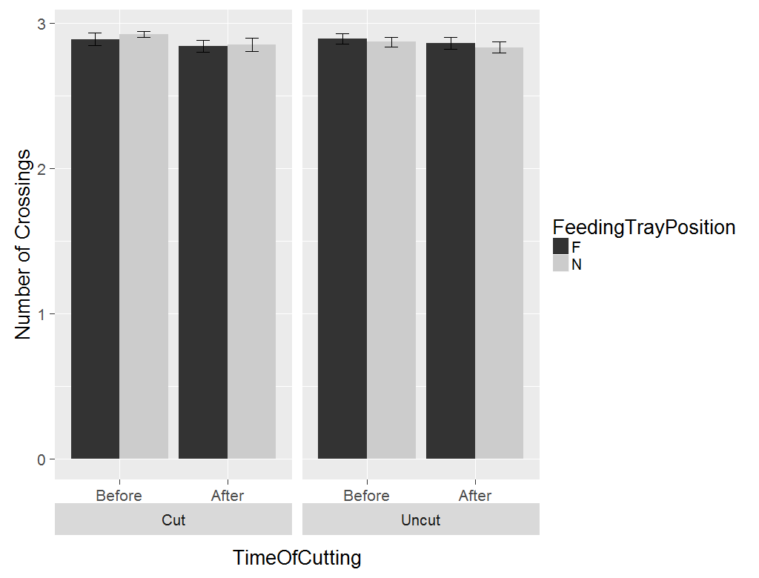

**Linear mixed effects model**

Analysis of Deviance Table (Type II Wald chisquare tests)

Response: GUD

Chisq Df Pr(>Chisq)

BefOnAft 12.5504 1 0.0003961 ***

cutUncut 0.2630 1 0.6080528

BefOnAft:cutUncut 0.9611 1 0.3269167

BefOnAft:cutUncut:NF 3.6736 4 0.4519807

---

Signif. codes: 0 ‘***’ 0.001 ‘**’ 0.01 ‘*’ 0.05 ‘.’ 0.1 ‘ ’ 1

**ANOVA with feeding station as an Error term**

Error: fStn

Df Sum Sq Mean Sq F value Pr(>F)

BefOnAft 1 0.02491 0.024914 1.345 0.276

cutUncut 1 0.00249 0.002487 0.134 0.723

BefOnAft:cutUncut 1 0.00270 0.002703 0.146 0.711

BefOnAft:cutUncut:NF 3 0.02595 0.008651 0.467 0.713

Residuals 9 0.16675 0.018527

Error: Within

Df Sum Sq Mean Sq F value Pr(>F)

BefOnAft 1 0.0524 0.05238 12.155 0.000749 ***

BefOnAft:cutUncut 1 0.0039 0.00387 0.897 0.345959

BefOnAft:cutUncut:NF 4 0.0146 0.00366 0.850 0.497416

Residuals 93 0.4008 0.00431

**Number of feeding stations visited**

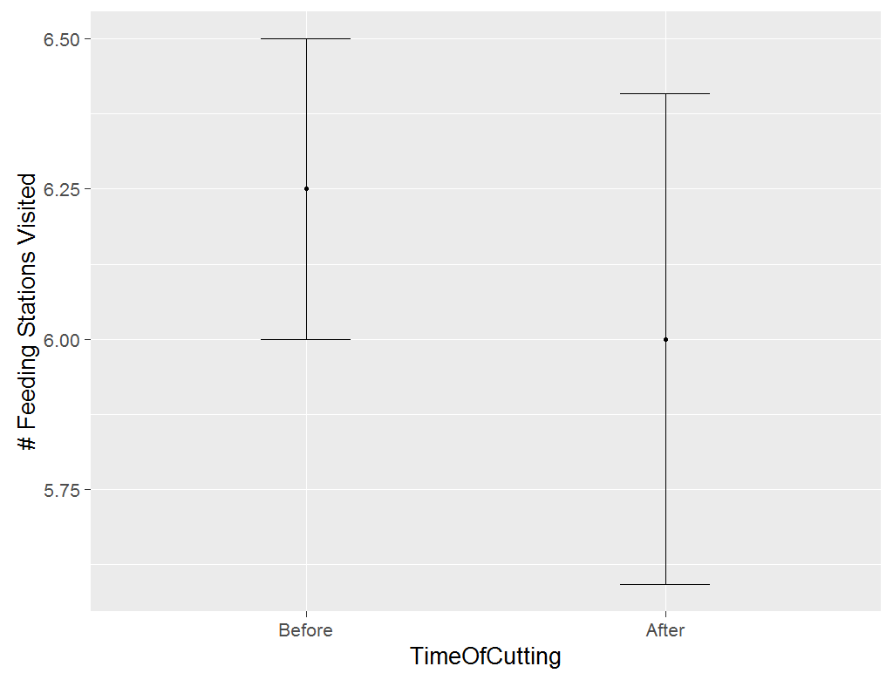 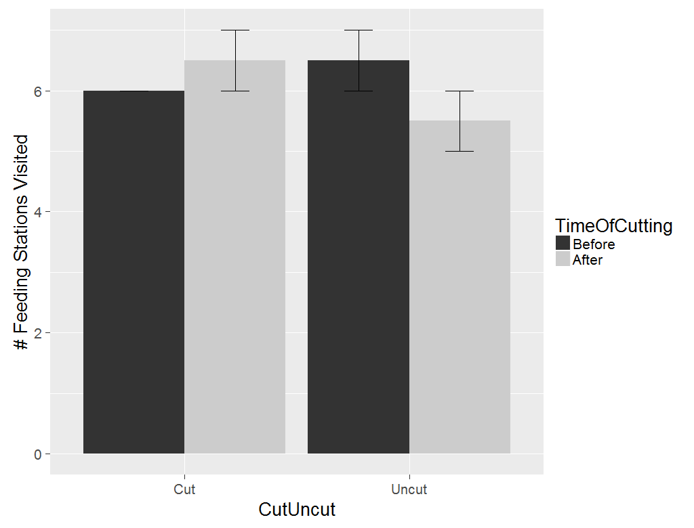

ANOVA

Time of cutting taken as an Error term as there are 2 observations each for before cutting and after cutting

Error: BefOnAft

Df Sum Sq Mean Sq

BefOnAft 1 0.125 0.125

Error: Within

Df Sum Sq Mean Sq F value Pr(>F)

cutUncut 1 0.125 0.125 0.333 0.595

cutUncut:BefOnAft 1 1.125 1.125 3.000 0.158

Residuals 4 1.500 0.375